PRESS RELEASE

TODAY IS COMING TO IRELAND: NBC’S TODAY SHOW TO

BROADCAST LIVE FROM SHEEN FALLS LODGE

For the first time ever, the iconic US morning programme will broadcast all four
hours live from Ireland.

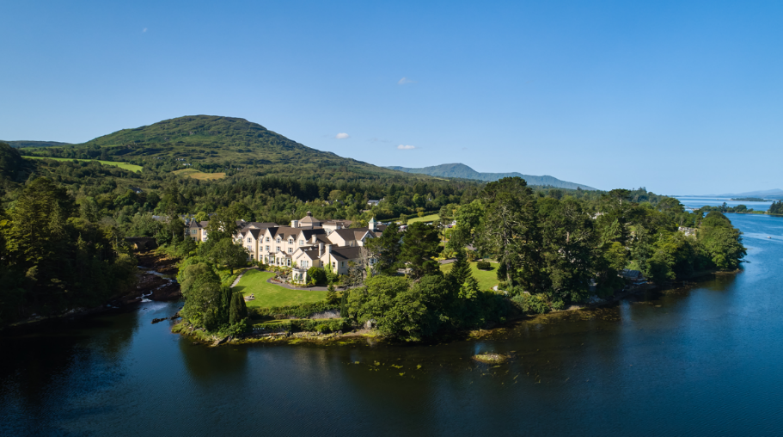

Kenmare, Co. Kerry – 10 September 2026: Sheen Falls Lodge is thrilled to announce that NBC’s TODAY will broadcast all four hours of their flagship weekday morning programme live from the five-star hotel in Kenmare, County Kerry, on Friday, 16 October 2026. The show is sponsored by Tourism Ireland. Sheen Falls Lodge is furnishing accommodations.

The landmark broadcast marks the first time TODAY will broadcast all four hours live from Ireland, bringing one of America’s most recognised morning television programmes to the country and millions of viewers a glimpse into the island of Ireland.

The special broadcast will see TODAY’s leading anchors and hosts, including Savannah Guthrie, Craig Melvin, Al Roker, Carson Daly, Dylan Dreyer, Jenna Bush Hager and Sheinelle Jones, travel to Ireland for a special four-hour programme.

Throughout the morning, TODAY will take viewers across the island of Ireland, sharing stories from its people and Ireland’s rich heritage, culture and authentic local experiences.

“We are delighted to welcome TODAY to Ireland. We hope it inspires viewers to come and experience the island of Ireland for themselves.” Alison Metcalfe, Executive Vice President, Head of North America, Tourism Ireland

For Sheen Falls Lodge, the broadcast represents an extraordinary opportunity to welcome an international audience to Ireland.

Set within 300 acres of woodland overlooking the meeting of the Kenmare Bay and Sheen River, the five-star hotel will provide the backdrop for this landmark international broadcast.
“We are delighted to welcome TODAY to Sheen Falls Lodge and to Kenmare for what will be a truly historic occasion. To have one of America’s most iconic morning programmes broadcast live from our hotel, is an incredible honour”. Brian Loughnane, General Manager, Sheen Falls Lodge
The TODAY team will be joined in Ireland by NBC News Chief International Correspondent Keir Simmons, with surprise celebrity guests also expected to feature throughout the special broadcast.

The four-hour live programme will offer viewers across the United States an engaging introduction to Ireland, its people, culture, heritage and unique experiences.

For more information on the broadcast, visit TODAY.com.

ENDS
Notes to editors:
TODAY will broadcast live from Sheen Falls Lodge, Kenmare, County Kerry, on Friday, 16 October 2026. The four-hour broadcast is presented in partnership with Tourism Ireland.
ENDS

For further information or imagery, please contact
Caitlin Shea, Kennedy PR + Brand: cshea@kennedyprandbrand.ie

ABOUT SHEEN FALLS LODGE
Named No. 1 Resort in the U.K. and Ireland in the Travel + Leisure World's Best Awards 2026

Awarded Two Michelin Keys in both the 2024 and 2025 Michelin Keys selections

The Falls Restaurant included in the MICHELIN Guide Great Britain & Ireland 2026

Named Number One Resort in Europe in the Condé Nast Traveller Readers' Choice Awards 2025

Named Number One Resort in Ireland in the Travel + Leisure Best of Awards 2025

Included in the Travel + Leisure 500 List of the Best Hotels in the World 2026

The Falls Restaurant awarded the Wine Spectator Best of Award of Excellence in 2024, 2025 and 2026

Proud member of the prestigious Relais & Châteaux collection of exceptional hotels and restaurants

Sheen Falls Lodge is an award-winning five-star country house hotel set on the edge of Kenmare, overlooking the cascading Sheen Falls and surrounded by 300 acres of woodland in the heart of County Kerry. Since opening in 1991, the hotel has earned an international reputation for refined hospitality, exceptional dining and personalised service, establishing itself as one of Ireland's most distinguished luxury destinations.
Dining at Sheen Falls Lodge is led by Executive Head Chef Mark Treacy. Under his leadership, the kitchens are renowned for elegant, technically accomplished and forward-thinking cuisine. The Falls Restaurant offers an exceptional fine dining experience, while The Stables Brasserie provides contemporary cuisine in a relaxed and welcoming setting.
For golf enthusiasts, the Ring of Kerry Golf Club, owned and managed by Sheen Falls Lodge, is located just five miles from the hotel. This championship 18-hole, par 72 parkland and heathland course, designed by Eddie Hackett and Ron Kirby, enjoys panoramic views across Kenmare Bay and the Caha Mountains. Facilities include the celebrated Ladies View sixth hole, a driving range and the recently renovated Nua Vista Restaurant and Clubhouse.
Easanna Wellness & Spa offers a peaceful sanctuary with a curated menu of treatments from leading luxury wellness brands including SEABODY, Elemis and Ground Wellbeing, completing the exceptional guest experience at Sheen Falls Lodge.

THE MAYRANGE HOSPITALITY PORTFOLIO
Mayrange Hospitality was established in 2018 by Dr. Stanley Quek and Peng Loh to acquire and develop impressive properties in great locations across Ireland. Both founders are committed to delivering the highest standards of comfort and service across accommodation, dining, events and golf. Each property within the collection is distinctive in style, celebrating its own unique character and Irish heritage while offering guests an exceptional and authentic experience.
The portfolio includes the award-winning five-star Sheen Falls Lodge in Kenmare, Co. Kerry, home to The Falls Restaurant, The Stables Brasserie and Bar, the Ring of Kerry Golf Club and Nua Vista Restaurant. It also includes the historic five-star Castlemartyr Resort in Co. Cork, featuring the Michelin-starred Terre restaurant, Canopy restaurant and The Hunted Hog gastropub; four-star Tulfarris Hotel & Golf Resort in Co. Wicklow; and Trinity Townhouse together with Library Street restaurant in Dublin city centre.

