Sheen Falls Lodge Executive Head Chef Mark Treacy

To Showcase the Finest Flavours of Kerry On

NBC's Today Show

The live culinary segment is scheduled to air at approximately 2.50pm (local time) on

Friday, 16 October, as part of NBC’s TODAY live broadcast from Sheen Falls Lodge.

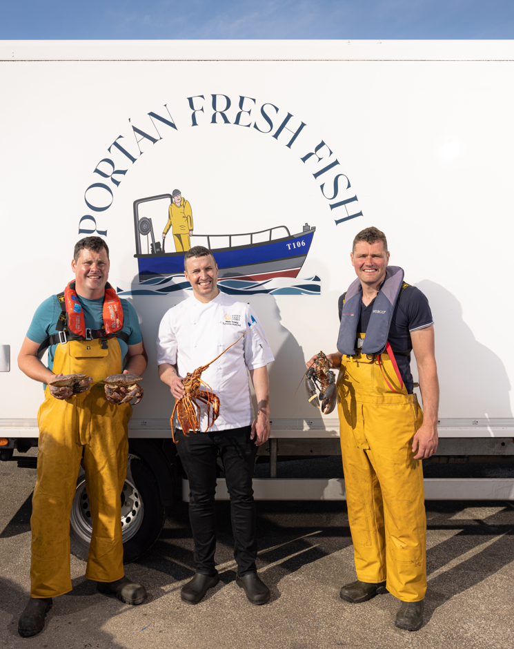
14 October 2026, Kenmare, Co. Kerry: The finest flavours of Ireland will take centre stage on American television this Friday, 16 October, as Mark Treacy, Executive Head Chef at five-star Sheen Falls Lodge, joins a special live culinary segment during NBC's TODAY show's four-hour broadcast from Kenmare. Set against the spectacular backdrop of the hotel's 300-acre estate overlooking Kenmare Bay, the segment will celebrate Ireland's exceptional culinary heritage, showcasing the finest local ingredients and artisan producers to millions of American viewers.
Joining Executive Head Chef Mark Treacy for the special live culinary segment will be three acclaimed culinary talents, award-winning chef and television presenter Mark Moriarty, celebrated chef and cookery author Catherine Fulvio, and internationally renowned baker and founder of Bigger Bolder Baking, Gemma Stafford.
Celebrating the exceptional produce of Ireland's southwest coast, Mark will showcase Portan Lobster, sourced from the pristine waters of Kenmare Bay, accompanied by silky carrot purée, a delicate lemon condiment and rich lobster bisque. He will also present Coolea Cheese Ravioli with Onion Broth and Truffle, a refined vegetarian dish highlighting the craftsmanship of Irish artisan cheesemakers.
Originally from County Clare, Chef Mark Treacy has overseen the culinary direction of The Falls Restaurant at Sheen Falls Lodge since 2021. Listed in The MICHELIN Guide Great Britain & Ireland, the restaurant offers an elegant expression of contemporary Irish cuisine, combining classical French techniques with the finest seasonal ingredients.
At the heart of Executive Head Chef Mark Treacy’s culinary philosophy is a commitment to provenance and longstanding relationships with local fishermen, farmers and artisan producers. From seafood landed along the Kerry coastline to organic vegetables and handcrafted cheeses, each ingredient reflects the richness of Ireland's natural larder.
“Lobster has always been part of our story at Sheen Falls Lodge. Our lobster is sourced locally from Kenmare Bay, which the hotel overlooks, and this dish is our way of honouring that connection,” Executive Head Chef Mark Treacy.
The landmark broadcast will showcase the spectacular setting and warm hospitality of Sheen Falls Lodge to millions of American viewers, placing the exceptional culinary heritage of Ireland firmly in the international spotlight.
ENDS

Notes to Editors
- TODAY will broadcast live from Sheen Falls Lodge, Kenmare, County Kerry, on Friday, 16 October 2026. The four-hour broadcast is presented in partnership with Tourism Ireland.
- High-resolution photography of Mark Treacy, the featured dishes and local suppliers is available on request. Full recipes are also available for editorial use.
ENDS

For further information or imagery, please contact
Caitlin Shea, Kennedy PR + Brand: cshea@kennedyprandbrand.ie

ABOUT SHEEN FALLS LODGE
Named No. 1 Resort in the U.K. and Ireland in the Travel + Leisure World's Best Awards 2026

Awarded Two Michelin Keys in both the 2024 and 2025 Michelin Keys selections

The Falls Restaurant included in the MICHELIN Guide Great Britain & Ireland 2026

Named Number One Resort in Europe in the Condé Nast Traveller Readers' Choice Awards 2025

Named Number One Resort in Ireland in the Travel + Leisure Best of Awards 2025

Included in the Travel + Leisure 500 List of the Best Hotels in the World 2026

The Falls Restaurant awarded the Wine Spectator Best of Award of Excellence in 2024, 2025 and 2026

Proud member of the prestigious Relais & Châteaux collection of exceptional hotels and restaurants

Sheen Falls Lodge is an award-winning five-star country house hotel set on the edge of Kenmare, overlooking the cascading Sheen Falls and surrounded by 300 acres of woodland in the heart of County Kerry. Since opening in 1991, the hotel has earned an international reputation for refined hospitality, exceptional dining and personalised service, establishing itself as one of Ireland's most distinguished luxury destinations.
Dining at Sheen Falls Lodge is led by Executive Head Chef Mark Treacy. Under his leadership, the kitchens are renowned for elegant, technically accomplished and forward-thinking cuisine. The Falls Restaurant offers an exceptional fine dining experience, while The Stables Brasserie provides contemporary cuisine in a relaxed and welcoming setting.
For golf enthusiasts, the Ring of Kerry Golf Club, owned and managed by Sheen Falls Lodge, is located just five miles from the hotel. This championship 18-hole, par 72 parkland and heathland course, designed by Eddie Hackett and Ron Kirby, enjoys panoramic views across Kenmare Bay and the Caha Mountains. Facilities include the celebrated Ladies View sixth hole, a driving range and the recently renovated Nua Vista Restaurant and Clubhouse.
Easanna Wellness & Spa offers a peaceful sanctuary with a curated menu of treatments from leading luxury wellness brands including SEABODY, Elemis and Ground Wellbeing, completing the exceptional guest experience at Sheen Falls Lodge.

THE MAYRANGE HOSPITALITY PORTFOLIO
Mayrange Hospitality was established in 2018 by Dr. Stanley Quek and Peng Loh to acquire and develop impressive properties in great locations across Ireland. Both founders are committed to delivering the highest standards of comfort and service across accommodation, dining, events and golf. Each property within the collection is distinctive in style, celebrating its own unique character and Irish heritage while offering guests an exceptional and authentic experience.
The portfolio includes the award-winning five-star Sheen Falls Lodge in Kenmare, Co. Kerry, home to The Falls Restaurant, The Stables Brasserie and Bar, the Ring of Kerry Golf Club and Nua Vista Restaurant. It also includes the historic five-star Castlemartyr Resort in Co. Cork, featuring the Michelin-starred Terre restaurant, Canopy restaurant and The Hunted Hog gastropub; four-star Tulfarris Hotel & Golf Resort in Co. Wicklow; and Trinity Townhouse together with Library Street restaurant in Dublin city centre.

